**GESTURE DETECTION – AN INTUTIVE APPROACH**

The gesture detection has many kinds of applications in real life with integration of AI to it has a very great potential use cases.

One of the ideas revolving around my mind is the “***VIRTUAL GYM TRAINER***”.

There are more people who doesn’t want to get to gym and prefer a quite good home gym. For those people having a gym trainer would cost them , instead of having a gym trainer they can make use of a virtual gym trainer which is kind of alexa that helps them with their workout .

The *virtual gym trainer* helps them with the counts of number of bicep curl,jumping,shoulder press , posture , diet and also gives them a brief schedule about the workout plan which can also be customised at the user side.

**ALGORITHM - *MEDIAPIPE POSE LANDMARKER***

**MediaPipe landmarker helps us to detect landmarks of human bodies in image or video.** **This gives us the value of each body part at its appropriate location, allowing us to approach problems creatively and add whatever extra flavour we desire. This task uses machine learning (ML) models that work with single images or video. The task outputs body pose landmarks in image coordinates and in 3-dimensional world. The below shows the landmark that is returned by the model.**

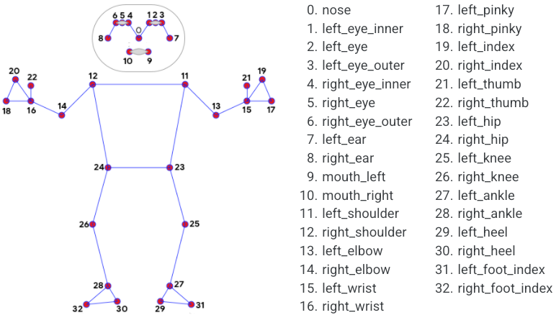

*Representing the landmark and respective body parts*

**SIMPLE FLOWCHART UNDERSTANDING OF WHAT THE METHOD DOES**

Video capture

Read the camera frame by frame

Initialize Mediapipe

Applying Pose Estimation

Read the camera frame by frame

Convert frame BGR to RGB

Applying Pose Estimation

Getting the land mark in results

The above is the flow the project has before every kind of prediction.Basically in this project we are making three AI driven Gym training model,

* BICEP CURL
* SHOULDER PRESS
* JUMP COUNTER

I utilised Mediapipe, which is Google's pretrained model, which is really helpful to assist us come up with innovative solutions. Other approaches, like Yolo versions, are also useful, and some pose estimation techniques are used in sports to help athletes develop, so our model can effectively integrate the techniques and help us have a full-time, monitored gym trainer at home.

**INNOVATIONS THAT CAN BE ADDED LATER**

I have extended my approach by having a hardware integrated with software that would help the individual one to get the report of their body progress in week or in a month .Our virtual gym trainer would give a detailed report of the calories burnt every day and keeping track of their ability to do the things quickly and efficiently.